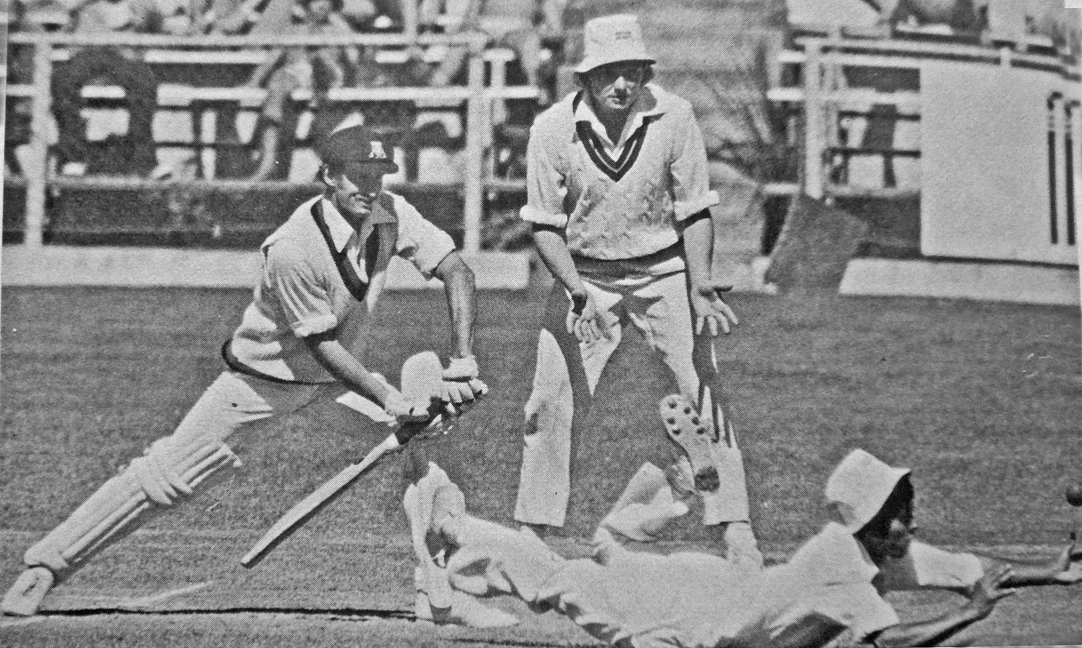

**Dayle Hadlee is relieved as Kirti Puna misses the catch. 3 January 1978 Lancaster Park**

**Canterbury 256/8 declared and 219. Northern Districts 289/6 declared and 39/2. Match drawn.**